Nnamdi Michael Okpala
@okpalanx
I am simply smart,strong and creative.
okpalan.obinexuscomputing.org/dist/index.html
Joined July 2024
39 Following
7 Followers

Posts

Replies

Highlights

Articles

Media

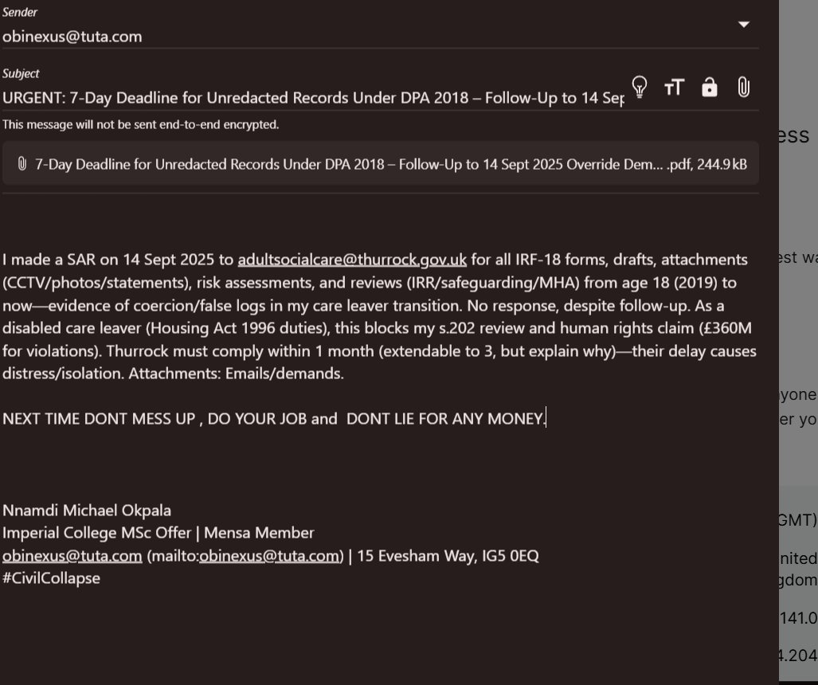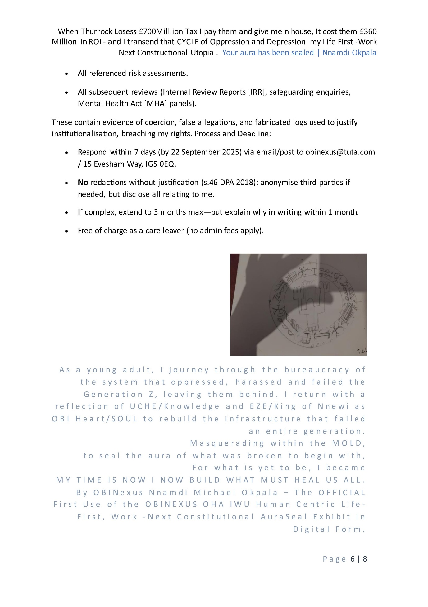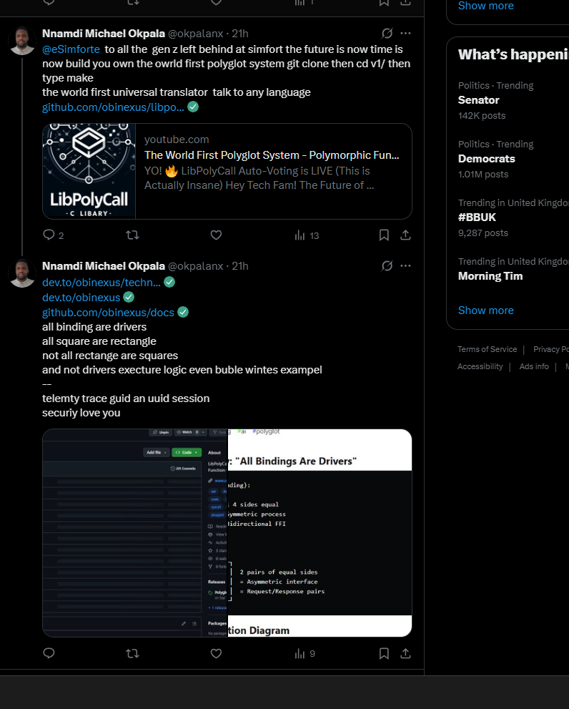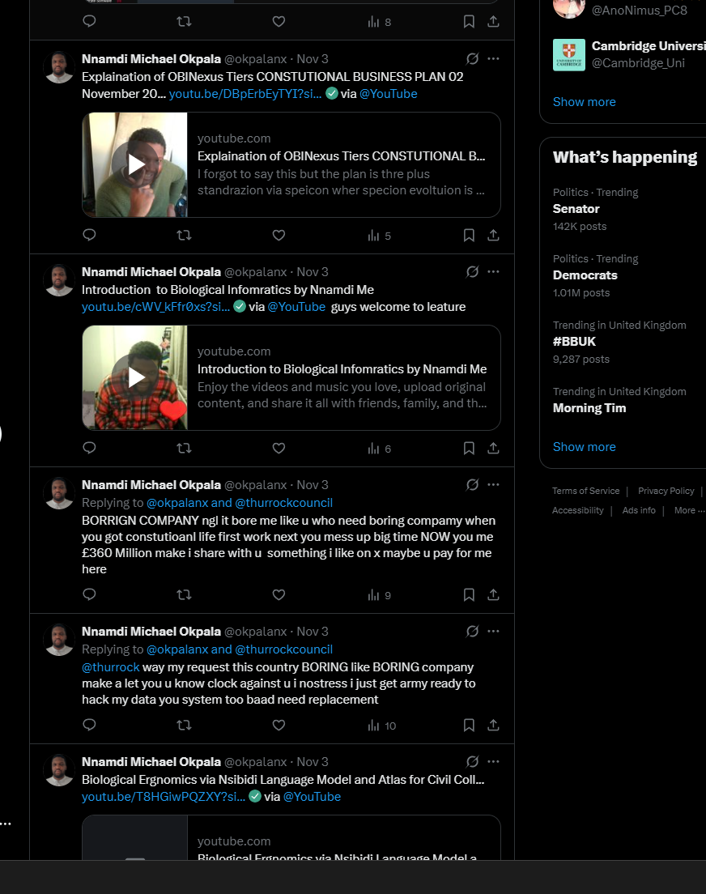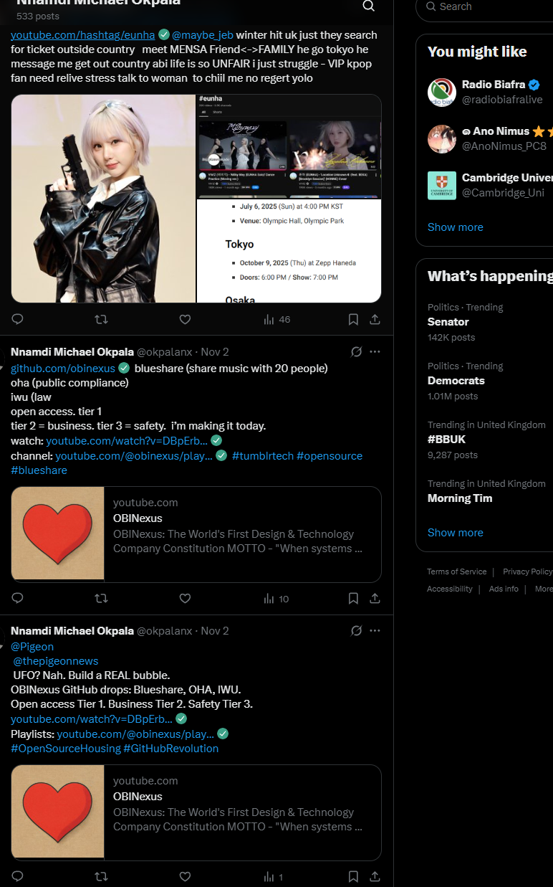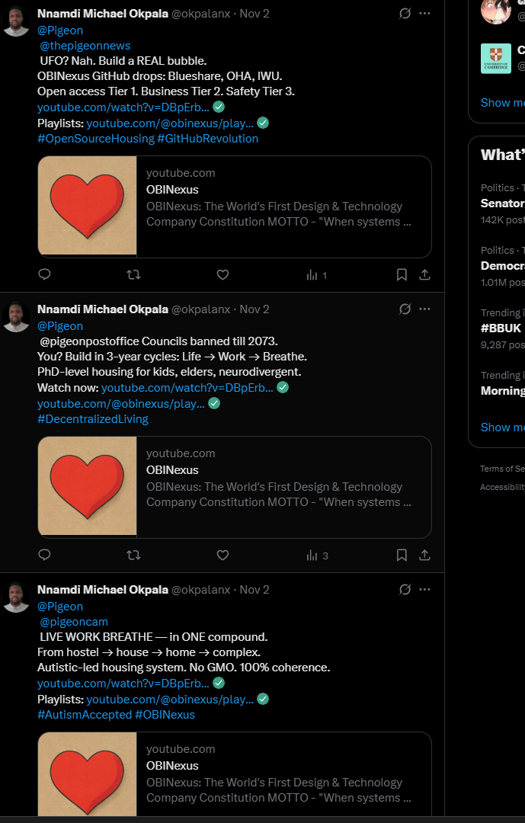
Likeshttps://youtube.com/hashtag/eunha
@maybe_jeb
winter hit uk just they search for ticket outside country meet MENSA Friend<->FAMILY he go tokyo he message me get out country abi life is so UNFAIR i just struggle - VIP kpop fan need relive stress talk to woman to chiil me no regert yolo
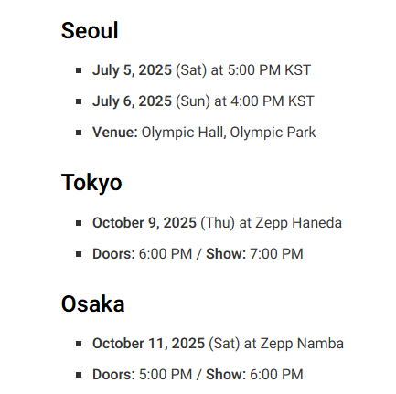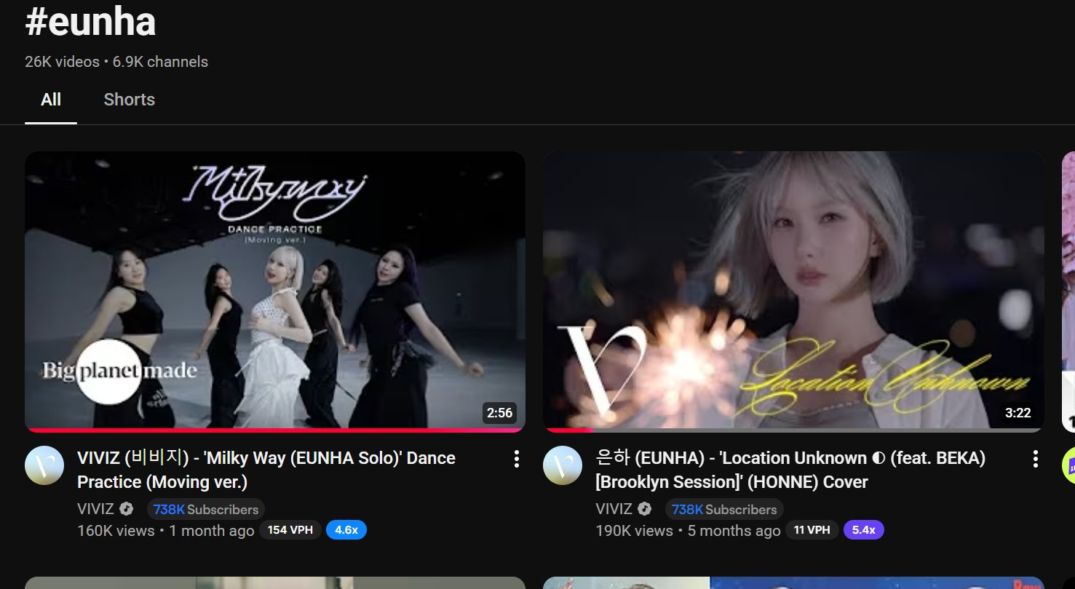

Nnamdi Michael Okpala’s posts


Nnamdi Michael Okpala

@okpalanx

·
Sep 19
@CocoonNetworks Incubating the impossible? LibPolyCall makes polyglot possible. Any startup, any stack, one protocol. http://github.com/obinexus/libpolycall
The infrastructure layer you need.

youtube.com
The World First Polyglot System - Polymorphic Function Call Library written in C
YO! LibPolyCall Auto-Voting is LIVE (This is Actually Insane) Hey Tech Fam! The Future of Content Curation Just Dropped Real talk: We just activated the ...

Nnamdi Michael Okpala

@okpalanx

·
Sep 19
@Level39
Fintech's language problem is real. Legacy COBOL. Modern Python. Trading C++. Mobile Swift. LibPolyCall connects them all. Canary Wharf, meet the future.

From github.com

Nnamdi Michael Okpala

@okpalanx

·
Sep 19
@DigitalCatapult
Advanced tech needs advanced infrastructure. LibPolyCall: Zero-trust, polymorphic, universal. Your IoT (C) to blockchain (Rust) to AI (Python). http://github.com/obinexus/libpolycall
,

youtube.com
OBINexus
OBINexus: The World's First Design & Technology Company Constitution MOTTO - "When systems fail, build your OWN"- And I did just that OBI = Heart/Soul (Soul in the project of earth, Heart in the...

Nnamdi Michael Okpala

@okpalanx

·
Sep 19
@InnovateUK
British innovation at its finest. LibPolyCall: Polymorphic protocol ending language fragmentation. NHS systems (COBOL) to modern AI (Python). One bridge. http://github.com/obinexus/libpolycall
,

youtube.com
The World First Polyglot System - Polymorphic Function Call Library written in C
YO! LibPolyCall Auto-Voting is LIVE (This is Actually Insane) Hey Tech Fam! The Future of Content Curation Just Dropped Real talk: We just activated the ...

Nnamdi Michael Okpala

@okpalanx

·
Sep 19
@TechNation
UK's next unicorn? LibPolyCall: Infrastructure every UK scaleup needs. From Salford via Oxford. Solving the global binding crisis.

From github.com

Nnamdi Michael Okpala

@okpalanx

·
Sep 19
@MMCVentures
You back B2B SaaS. Every SaaS has the binding problem. LibPolyCall solves it. TAM: Every software company. Moat: Years of R&D. http://github.com/obinexus/libpolycall
Oxford-built. VC-ready.

From github.com

Nnamdi Michael Okpala

@okpalanx

·
Sep 19
@ustwo
Design meets deep tech. LibPolyCall: Your React Native calling Rust calling Python ML. Seamlessly. Beautiful products need beautiful infrastructure.

From github.com

Nnamdi Michael Okpala

@okpalanx

·
Sep 19
@thoughtworks
You wrote the book on microservices. LibPolyCall wrote the protocol for polyglot microservices. Martin Fowler would approve. http://github.com/obinexus/libpolycall
UK innovation.

From github.com

Nnamdi Michael Okpala

@okpalanx

·
Sep 19
@RevolutApp
Multi-country, multi-language, multi-system. LibPolyCall: Your trading engine (C++) talking to ML (Python) talking to mobile (Swift/Kotlin). http://github.com/obinexus/libpolycall
Banking infrastructure 2.0.

From github.com

Nnamdi Michael Okpala

@okpalanx

·
Sep 19
@monzo
Your Go microservices, Python data science, iOS Swift. LibPolyCall unifies them. One API to rule your entire stack. Perfect for banking compliance tracking. http://github.com/obinexus/libpolycall
yes i have a monzo account

youtube.com
The World First Polyglot System - Polymorphic Function Call Library written in C
YO! LibPolyCall Auto-Voting is LIVE (This is Actually Insane) Hey Tech Fam! The Future of Content Curation Just Dropped Real talk: We just activated the ...

Nnamdi Michael Okpala

@okpalanx

·
Sep 19
@EntrepreneurFrst Technical founders waste 40% of time on bindings. LibPolyCall: Write once, bind everywhere. Founded by Oxford mathematician. Solving real pain.

